MSc Software Design with AI

Advanced Machine Learning and - (AL_KSAIM_9_1)

Assignment 1 – option 1

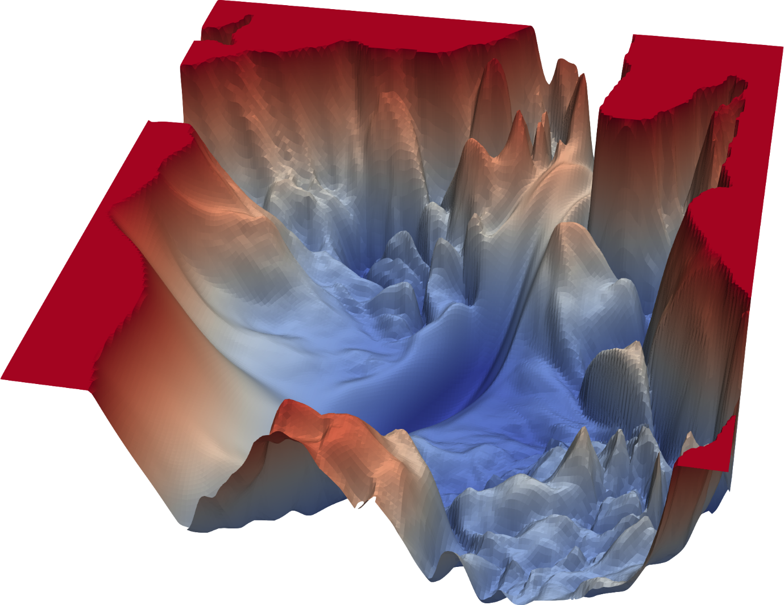

Survey of Modern Neural Architectures for Game AI

Andrew Nolan

A00325359@student.tus.ie

7th May 2025